Text to Braille

Aim:
To get text input from user and convert that text into braille virbations using coin motors grid of 3x1.

components:
Esp32(1),
coin motors/vibrating motors(3),
flyback diodes (3)
inbuilt laptop Keyboard.

Circuit Diagram:
overall connections:
(initial attempt)
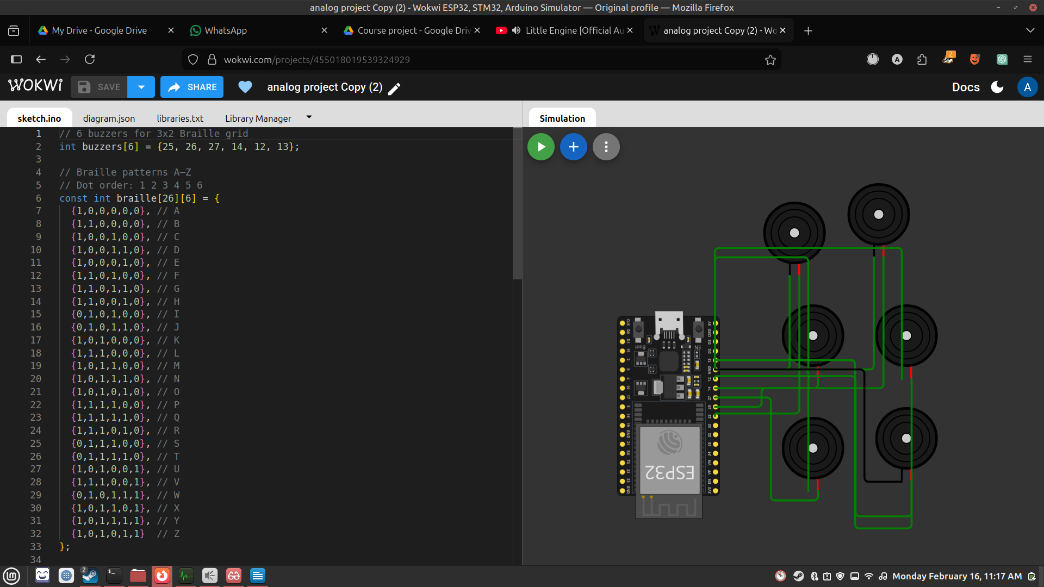
single motor connection:
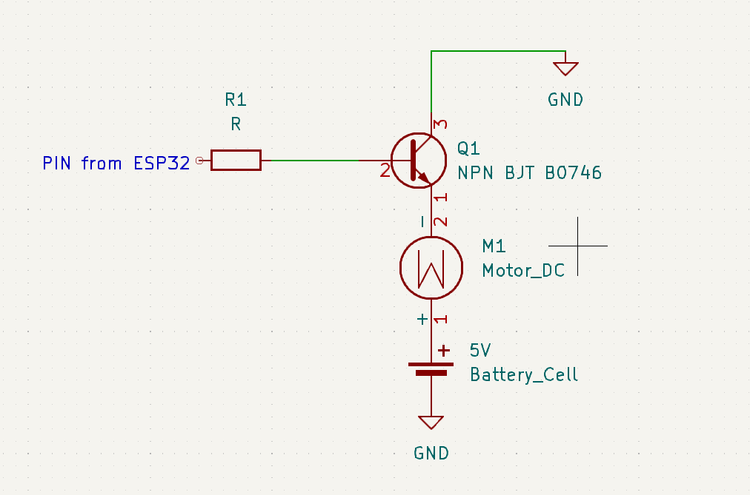

Flow chart:
3x1 Grid of coin motors
Here braile vibrations are felt
Text input on
Laptop

Esp32
Converts
Letters into respective Grid vibrations

Input (Keyboard) → ESP32 Microcontroller → Motor Driver Circuit → Coin Vibrating Motors (3x1 Grid) → Braille Output (Vibration Pattern)

working/operation:
The system takes text input from the user through a laptop keyboard. The ESP32 processes this input and converts each character into its corresponding Braille representation. Each Braille character is mapped to a specific vibration pattern using a 3x1 grid of coin motors.
When a character is entered, the ESP32 activates specific motors based on the Braille encoding. The motors vibrate in patterns that represent raised dots in Braille, allowing the user to feel and interpret the text.
Each component works as follows:
- ESP32: Processes input and controls output
- Coin Motors: Generate vibrations representing Braille dots
- Flyback Diodes: Protect the circuit from voltage spikes
- Keyboard: Provides user input

Hardware Setup:
- ESP32 board placed on breadboard
- 3 coin motors arranged in a 3x1 grid
- Each motor labeled as Dot 1, Dot 2, Dot 3
- Flyback diodes connected parallel to each motor
- Wires properly color-coded (VCC, GND, Signal)
- USB cable used for power and programming

Application of the Project :
The ESP32-based text-to-Braille project is a highly useful assistive technology designed to help visually impaired individuals access written information independently. By converting digital text into tactile Braille output, it enables users to read messages, documents, and educational content without relying on audio aids. The system can also support real-time text conversion through wireless communication features like Bluetooth or Wi-Fi, making it suitable for modern applications such as smartphones and smart devices. Additionally, it serves as an effective educational tool for learning Braille and offers a low-cost alternative to expensive commercial Braille displays. Overall, this project enhances accessibility, promotes independence, and improves the quality of life for users with visual impairments.

Project image:
